Tutor: James Tedder
Games Designer: YOURNAMEHERE

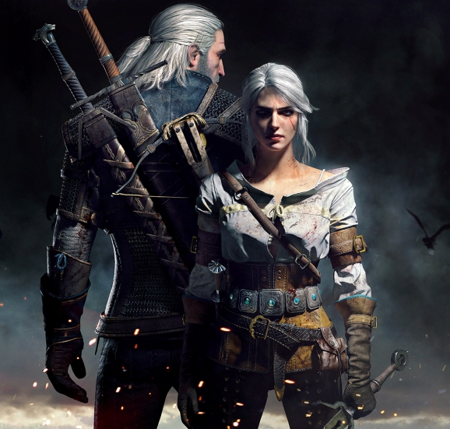
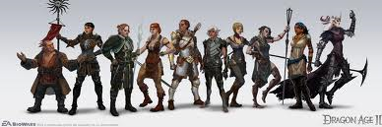
Game Design
Principles

Game Design Principles
Task 1 - Glossary of terms
You will be assigned a term. You need to create a one sentence definition for the term and explain it to the rest of the class. Make a note of the definition on the pages below. It must be in your own words. (10 mins)
As other people read out their definitions complete the table on the next pages

Game Play Mode | Definition
Omnipresence
On-line
Single Player
Multiplayer
Co-operative

Genre | Definition
FPS
TPS
RACING
ADVENTURE
PUZZLE
ROLE PLAY
SIMULATION
TBS
RTS

Perspective | Definition
2D
3D
First Person
Third Person
Scrolling
Top Down

Task 2 – Themes
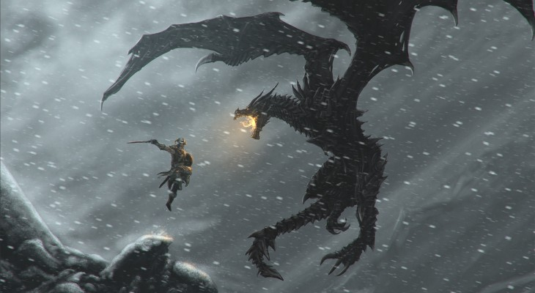
Theme | Definition
VENGENCE
HAPPINESS
FEAR
ANGER
PERSEVERANCE
HEROISM
VALOUR
HOPE
COMPETITIVENESS

Task 3 - Mission Impossible
Choose at least one option from each of the four areas.

Your mission is to convince your tutor that you have found a game that meets as many of the four components you have been assigned as possible.
You will need to be able to prove that the game you’ve chosen meets the four principles by explaining it to another student in the class and by producing a 2-page review.
You will need to
A – Find a Video Trailer for the Game
B – Find actual Game Play Footage
C – Produce a review of the game, specifically indicating which Theme, Genre, Mode of Game Play and Perspective it covers. You will need to justify your conclusions. Include links to the video clips
You will score 10 points for each of the four principles you include as long as your review is convincing enough.
You can gain extra points by proving that your game covers additional themes, genres, modes and perspectives.

Theme | Genre | Game Play Mode | Perspective
VENGENCE | FPS | Omnipresence | 2D
HAPPINESS | TPS | On-line | 3D
FEAR | RACING | Single Player | First Person
ANGER | ADVENTURE | Multiplayer | Third Person
PERSEVERANCE | PUZZLE | Co-operative | Scrolling
HEROISM | ROLE PLAY |  | Top Down
VALOUR | SIMULATION
HOPE | TBS
COMPETITIVENESS | RTS

