Rough guide to your design plan (Task 1)
Submit plan for feedback: 3/5/18
Look back at your previous assignment. Anything you can reuse/help with the design plan? Justify your decisions and selections throughout.
Things to include:
- Include minimum specs of software needed and extra costs involved
- Hardware specs and recommendations for upgrades including costs.
- Network Layout diagram – See next page for example – Ms Visio could be used
- What services need to be configured - DNS, DHCP, Active Directory, Printer services etc. Why?
- Backup Software? (e.g Windows Server Backup, Acronis. Which and why.)
- Disaster recovery setup - Devise a regular backup plan – where will this data be stored? How?
- Anti Virus?
- Explain those services and there uses with the network
- User name and passwords for users
- Access Rights?
- Explain the router setup(Firewall, encrypted WI-FI)
- Explain your intruder detection system e.g firewall
- Physical security(Server room access)
- Testing (Explain what and why you are using them):
  - User functionality test (Do all the features you have set up work)
  - Network security and penetration testing: e.g Kali Linux with OpenVas. Checking security configurations.
  - Network speed: e.g Lan Speed Test
  - Internet speed: e.g speedtest.net
- You will need to put a test plan together for the above.
Current network setup:
Old server with no NOS installed:  Processor: Core 2 Duo  Hardrive: 500GB HDD  RAM: 4GB | 8 Dell PC’s all running Windows 7:  Processor: Core 2 Duo  Hardrive: 500GB HDD  RAM: 2GB

Note: If upgrading or suggesting new hardware remember it is a small business(consider value and need) and you must justify your selection.
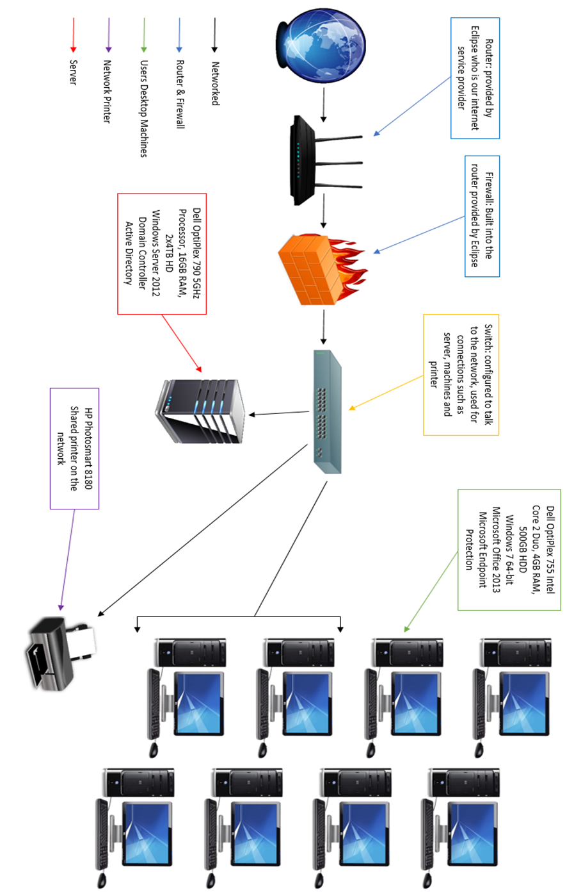
Network Diagram Example

