Rough guide to your design plan (Task 1)
Submit plan for feedback: 1/4/19
Look back at your previous assignment. Anything you can reuse/help with the design plan? Justify your decisions and selections throughout.
Things to include:
Installation
- Outline and select all hardware, software (Could also include cabling) for the network. Reflect back to assignment 1. Infrastructure or standalone? Storage requirements? Which NOS will you use?
- Include minimum specs of software needed and extra costs involved.
- Hardware specs and recommendations for upgrades including costs.
- Include existing hardware and software here along with items to be bought.
- Network Layout diagram – See next page for example – Ms Visio/www.draw.io could be used
Service
- What services need to be configured - DNS, DHCP, Active Directory, Printer services etc. Why?
Naming system
- Domain name and local server name.
- User name and passwords for users. Use a table.
Addressing: method eg allocation of addresses for NOS services
- IP Address list for hardware.
Security
- Policy eg patch management, anti-viral management, access requirement/rights, administrative rights, authentication, password policy.
- Explain your intruder detection system e.g firewall with filers and rules, email monitoring, application and packet monitoring
- Physical security(Server room access)
- Explain the router setup(Firewall, encrypted WI-FI)
- Anti-Virus

Disaster recovery
- Disaster recovery setup - Devise a regular backup plan/methodology – where will this data be stored? How? Backup-power supply? Off site management? How will you ensure high availability and fault tolerance.
- Backup Software? (e.g Windows Server Backup, Acronis. Which and why.)
Security Policies & Procedures to consider
- Password(timeout, requirements, history)
- Security(Group policy, CCTV, guards, check points)
- Vetting (DBS, CRB, references)
- Physical protection (Doors & locks)
- Encryption(Bitlocker etc)
- Timeout(Session, PC, User account)
- User roles (Admin, non-admin, restricted admin, guest)
- Backup & Data evacuation
- Data protection act, GDPR
- Two factor Authentication (Software, hardware, physical)

Current network setup:
Old server with no NOS installed:  Processor: Core 2 Duo  Hardrive: 500GB HDD  RAM: 4GB | 8 Dell PC’s all running Windows 7:  Processor: Core 2 Duo  Hardrive: 500GB HDD  RAM: 2GB

Other hardware:
Switch
CAT 5 Cabling with patch panel
Router (With WiFi)
Printer
See assignment scenario for software
Note: If upgrading or suggesting new hardware remember it is a small business (consider value and need) and you must justify your selection.
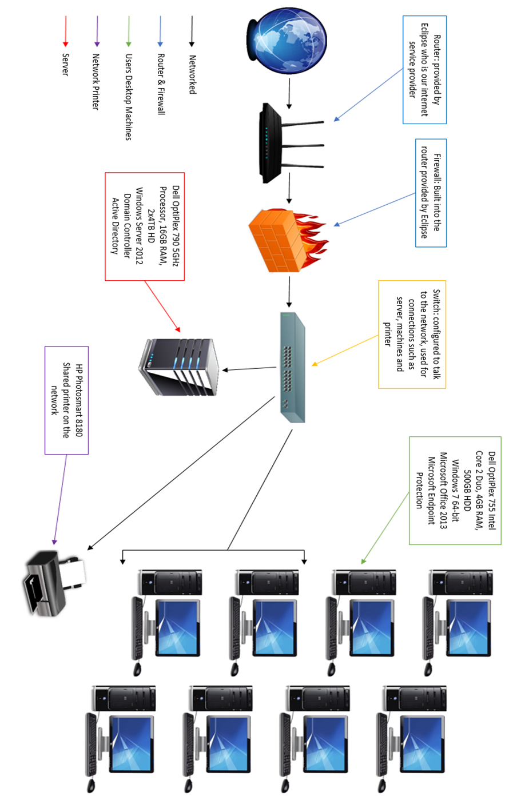
Network Diagram Example

